Automation Projects

Major Projects:

* PhoenixBaseTest
* PhoenixPoliceTest
* PhoenixFireTest
* PhoenixIATest

## PhoenixBaseTest Project: -

* It’s an independent Project for police and Fire RMS, this project includes major modules functionality, defect, enhancement & Release Broken scripts.
* These projects are split by modules of police RMS it divides as:
  + - PhoenixBaseTest
    - PhoenixPoliceTest
* The PhoenixPoliceTest & PhoenixFireTest projects having references with PhoenixBaseTest Project.
* From the Base Project Scripts are initiated through XML files, XML files are classified into versions by folder.
* 2020R2 we are using this to run Scripts against 1.78
* 2022 we are using this to run Scripts against 1.68

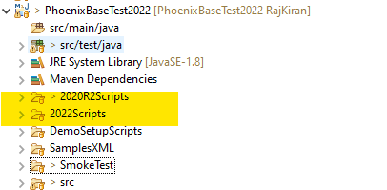

### Detailed view of Xml suites File:

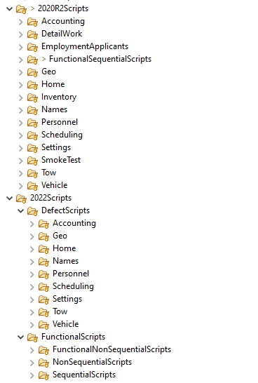

* The folder classified for each version consists of separate modules folders with Functionality, Defect & Release Broken Suites files,
* we are not creating defect folder as individual in 2020R2, its included as per respected module folder:

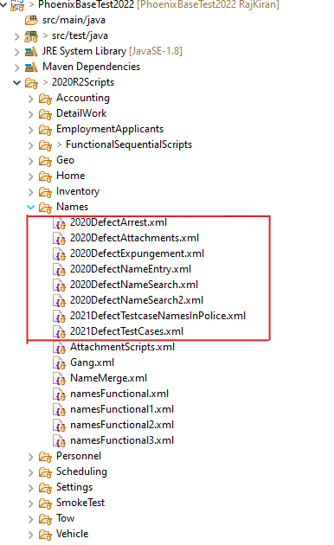

* Defect folder is separately created for individual modules in 2022 folder.

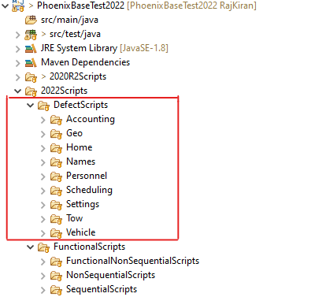

### Functional Scripts: -

And functional Scripts for every individual module its divided as:

* Sequential Scripts
* Non- Sequential Scripts

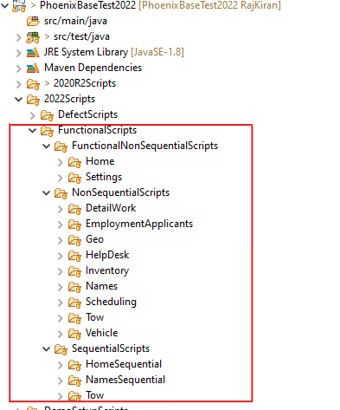

### Major Modules Suite Folder in BaseProject: -

* Home
* Name
* Geo
* Personnel
* Inventory
* Vehicle

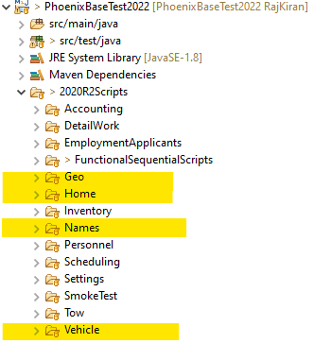

### Smoke Test Folders:

Smoke Scripts also segregated by version as:

* BaseSmokeTest
* CMSBaseSmokeTest
* SettingsSmokeTest

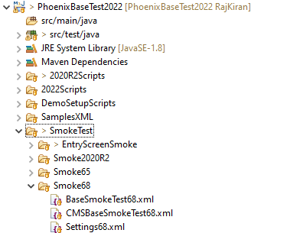

For Enty Screen smoke test are created for every module it been separated as folders by module name.

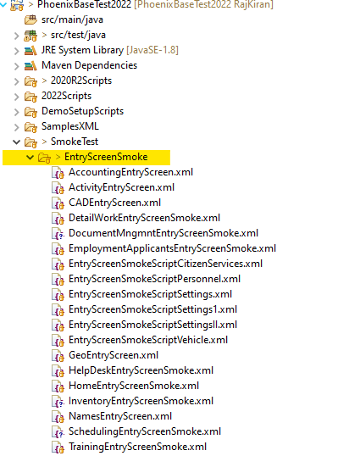

## PhoenixPoliceTest Project: -

* It’s an dependent project of base project, it having separated folders by versions with Functionality, Enhancement, defect & Release Broken Xml suite Files.
* The PhoenixPoliceTest project having references with PhoenixBaseTest Project.
* Created separate folder for both versions 2020R2 & 2022 for hold the files to respective module.

### Detailed view of Xml Suite Files:

For both 2022 & 2020R2 folder we created the defect & functional for each module.

* + 2020R2 we are using this to run Scripts against 1.78
  + 2022 we are using this to run Scripts against 1.68

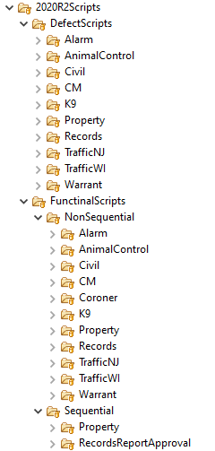

### FunctioanlSuites

And functional Scripts are divided as:

* Sequential Scripts
* Non- Sequential Scripts

### Major Suite Folder Police Project:

* Records
* Property
* Traffic NJ
* Traffic WI
* K9
* Warrant
* CM

### Report Related Suite files:

In police RMS, Report Process Having one of the major Role. For that we are having separate Scripts and Xml Suite Files under Sequential.

### Smoke Test Folders:

Smoke Scripts also segregated by version as:

* + - PoliceSmokeTest

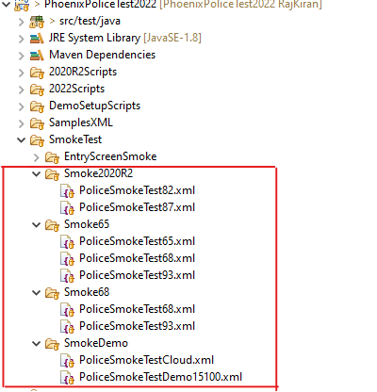

Enty Screen smoke test created for every module it been separated as folders by module name.

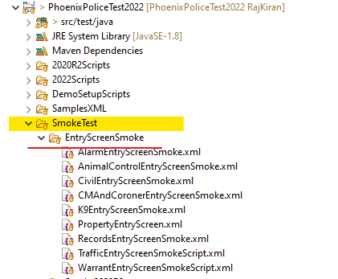

## PhoenixFireTest Project: -

This project creates for Fire RMS product so its totally used to run against fire product for both version 2022 & 2020R2

* It’s a dependent project of base project, it having separated folders by versions with Functionality, Enhancement, defect & Release Broken Xml suite Files.
* The PhoenixFireTest project having references with PhoenixBaseTest Project
* Created separate folder by versions 2020R2 &2022, the folder holds Xml files for respective module

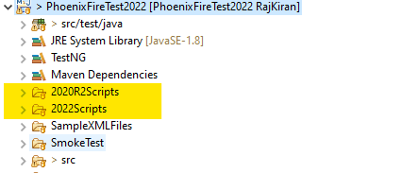

### Detailed view of Xml:

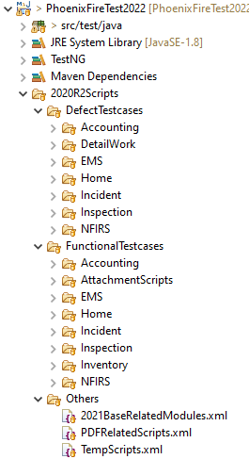 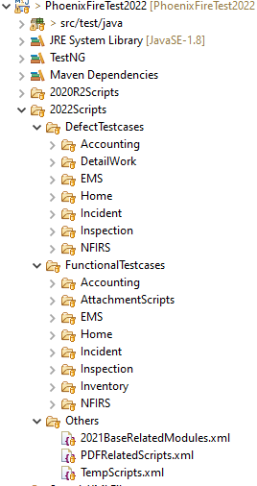

### Functional scripts:

* In fire project in both version of Xml folders .We are not seperating functiaonal Xml like Sequential & non sequential.
* Both Sequntial and non - sequential Xml is include in the same folder for the respective module

IN 2020R2 version folder:

In 2022 versions folder:

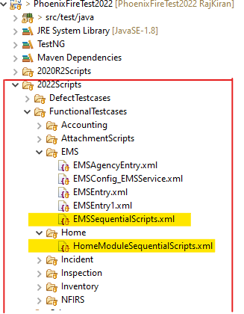

### Major suite folder in Fire project:

* EMS
* NFIRS
* Incident
* Inspection

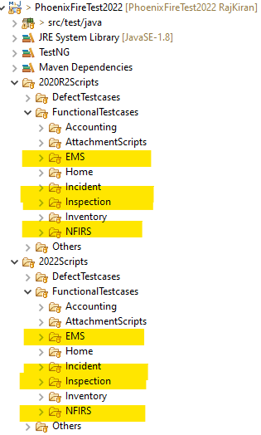

### Smoke Test Folders:

Smoke Scripts also segregated by Product and version :

* Fire Module-Fire Product related modules
* Base Module-Police product related modules

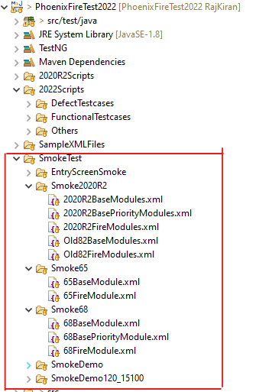

Enty Screen smoke test created for every module it been separated as folders by module name

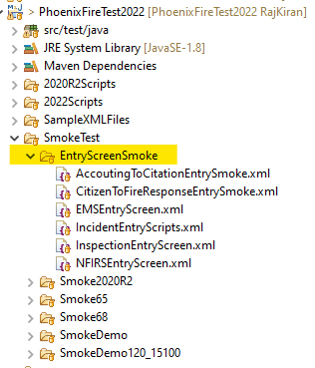

## PhoenixIATest Project: -

* It’s an independent Project for IA Product, this project includes major modules functionality, defect, enhancement & Release Broken scripts.
* From the IA Project Scripts are initiated through XML files, XML files are classified into versions by folder.
* 2020R2 we are using this to run Scripts against 1.78
* 2022 we are using this to run Scripts against 1.68

### Detailed of Xml Suite File:

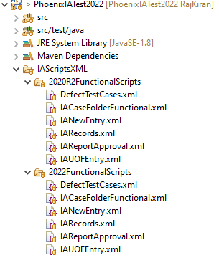

### Functional scripts:

* In IA project in both version of Xml folders .We are not seperating functiaonal Xml like Sequential & non sequential.
* Both Sequntial and non - sequential Xml is include in the same folder for the respective module .

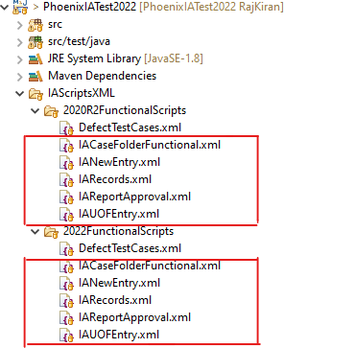

### Major module suite Folder in IA Project

* IA CaseFolder
* IA Records
* IAReportApproval
* IAUOFEntry

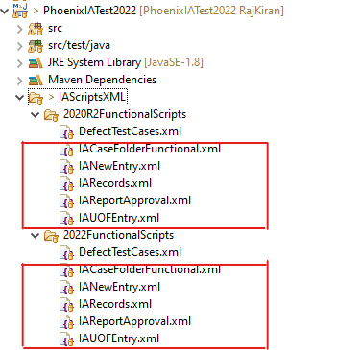

### Smoke Test Folders:

It’s an independent project its having Smoke Scripts for IA product only, also segregated by version as:

* Smoke2020R2
* Smoke2022

Entry Smoke In IA Project has been divided as:

* BaseRelatedModules - Police Product Related Modules are included
* IA Modules - IA Related Modules are included

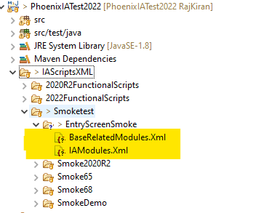

-THE END-